Reinforcement learning (RL) is all about an agent learning to take actions in an environment to maximize its reward. Dynamic programming (DP) comes in handy as a powerful tool for solving planning problems within RL, especially when the agent has a perfect model of the environment.

Here's the gist of how dynamic programming helps in RL:

**Perfect Model Advantage:**

* Dynamic programming works best when the agent has a complete understanding of the environment. This means it knows the transition probabilities (landing in a particular state after taking an action from another state) and the reward structure (rewards for being in specific states).

**Breaking Down the Problem:**

* Dynamic programming tackles complex problems by breaking them into smaller, more manageable subproblems. In RL, these subproblems can represent the value of being in a particular state or taking a specific action in a state.

**Optimality and Overlap:**

* Two key concepts underpin dynamic programming:
  + Optimal substructure: The optimal solution to the overall problem can be built from solutions to the subproblems.
  + Overlapping subproblems: The same subproblems appear multiple times. DP cleverly stores solutions to these subproblems and reuses them, saving on computation.

**Finding the Best Policy:**

* Dynamic programming algorithms use value functions like state-value function (v*) and action-value function (q*) to guide the search for an optimal policy. These functions estimate the long-term rewards the agent can expect from being in a state (v*) or taking an action in a state (q*).

**Benefits and Limitations:**

* While DP is a great tool for finding optimal solutions in environments with perfect models, it has limitations:
  + Real-world environments are rarely perfectly known, making it challenging to apply DP directly.
  + DP algorithms can be computationally expensive for very large or continuous state spaces.

**Overall, dynamic programming provides a solid foundation for understanding RL and serves as a benchmark for optimal performance. It paves the way for exploring other RL algorithms that can handle more complex and uncertain environments.**

what is value function

In reinforcement learning, a value function is like a crystal ball for the agent, helping it predict how good (or bad) things will be in the long run. It's a function that estimates the future rewards the agent can expect based on the current situation. There are two main types of value functions:

1. **State-Value Function (v(s))**: This function predicts the expected future reward the agent can get, starting from a specific state (s) and following the current policy (the way the agent chooses actions). In simpler terms, it tells the agent how good it is to be in a particular state.
2. **Action-Value Function (q(s, a))**: This function goes a step further. It estimates the expected future reward the agent can expect by taking a specific action (a) in a given state (s) and then following the current policy. So, it tells the agent not only how good a state is, but also how good it is to take a particular action in that state.

Here's a breakdown of some key points about value functions:

* **Future Rewards**: They consider not just the immediate reward the agent receives for an action, but also the expected rewards it can get in the future based on the chosen policy.
* **Discounting**: Since future rewards are generally less valuable than immediate ones (think getting a reward today versus a year from now), value functions use a discount factor (gamma) to weigh the importance of future rewards. Rewards further in the future are discounted more.
* **Policy Dependence**: The value functions (both state and action) depend on the current policy the agent is following. A different policy would lead to different future actions and hence different expected rewards.

By learning and updating these value functions, the agent can make informed decisions. It can choose actions in states that are predicted to lead to higher future rewards in the long run.

Here's an analogy: Imagine you're playing a game. A value function is like a scorecard that not only shows you the points you get for your current move, but also estimates how many points you might get in the future based on the strategies you typically use. This helps you choose moves that will maximize your overall score.

The Bellman equation is a fundamental concept in dynamic programming (DP) and reinforcement learning (RL). It expresses a key principle: the **optimality principle**. Let's break it down:

**Imagine you're on a journey:**

* You're on a road trip across a country, and your goal is to reach the final destination with the best possible experience (think beautiful sights, interesting stops, etc.).
* The road trip represents the **environment** in RL. There are many towns (states) you can visit, and different roads (actions) you can take to get between them.

**Making the Most of Your Trip:**

* You want to make the most of your time and resources. This translates to maximizing the **long-term reward** in RL. Rewards can be positive (enjoyable experiences) or negative (traffic jams, bad weather).

**The Optimality Principle:**

* The Bellman equation embodies the idea that the best overall decision you can make at any point on your trip depends on the best decisions you can make at *future* stops.
* In other words, to get the best overall experience, the choice you make now should lead to the best possible remaining journey.

**The Math Behind the Magic:**

* The Bellman equation is written mathematically, but the core idea is quite intuitive. Here's a simplified version:

**V(s) = R(s, a) + γ * max(V(s'))**

Let's break down the symbols:

* **V(s)**: This represents the **value** of being in state **s**. It estimates the total future reward you expect to get if you start from state s and follow the **optimal policy** (the best course of action at each point).
* **R(s, a)**: This is the immediate **reward** you get for taking action **a** in state **s**.
* **γ (gamma)**: This is a **discount factor** (usually between 0 and 1). It reflects the importance of future rewards. Rewards further down the road are discounted more because they are less certain.
* **max(V(s'))**: This represents the **maximum** value of all the possible future states (s') you could land in after taking action a from state s. It essentially considers all the potential remaining journeys and picks the one with the highest expected value.

**Putting it Together:**

* The Bellman equation essentially says:
  + The value of being in a state (V(s)) is equal to:
    - The immediate reward you get for taking an action (R(s, a))
    - PLUS
    - The discounted value of the best possible remaining journey (γ * max(V(s')))

**Why is it Important?**

* The Bellman equation allows us to iteratively compute the value function for each state. We start from the end goal (where the journey is complete and the value is known) and work backward, calculating the value of each preceding state based on the values of its successor states.
* Once we have the value function, finding the optimal policy becomes straightforward. We simply choose the action in each state that leads to the state with the highest value.

**Remember:**

* The Bellman equation assumes a perfect understanding of the environment (knowing all rewards and transitions). This is rarely true in real-world RL.
* However, it provides a foundation for understanding how value functions and the optimality principle guide the search for good policies.

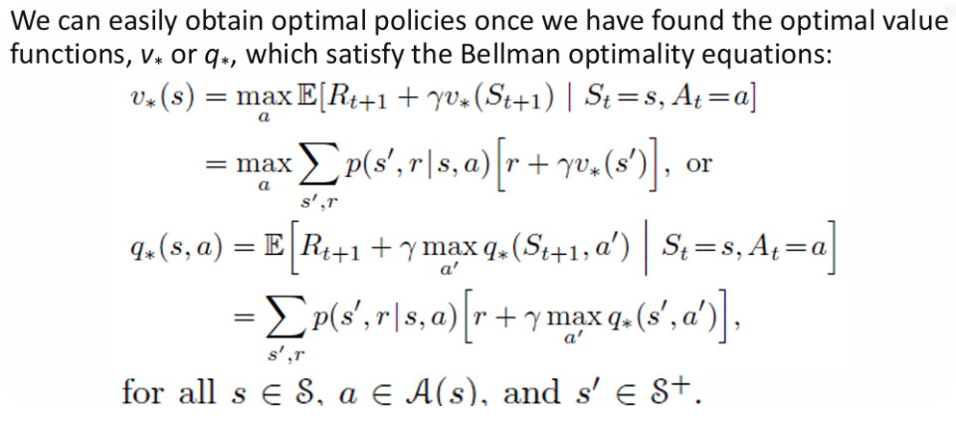

, the image you sent depicts the Bellman optimality equation, which is a cornerstone of dynamic programming (DP) in reinforcement learning (RL). The equation expresses the relationship between the value of a state (or action-value) and the expected value of its successor states.

Here's a breakdown of the equation and the corresponding parts in the image:

* *v(s)*\* (written as "v*" in the image) represents the optimal state-value function. It estimates the expected long-term reward an agent can incur, starting from state "s" and following the optimal policy thereafter.
* **max** (written as "max" in the image) signifies that the agent should choose the action that leads to the highest future value.
* *E[Rt+1 + γv(St+1) | St=s, At=a]*\* (written as "E[Rt+1 + γu*(St+1) | St=s, At=a]" in the image) represents the expected value starting from state "s", taking action "a", and transitioning to state "St+1". Here's a breakdown of the terms:
  + **E[]**: denotes the mathematical expectation.
  + **Rt+1**: represents the immediate reward received after taking action "a" in state "s" and landing in state "St+1".
  + **γ (gamma)**: is the discount factor, used to weigh the importance of future rewards. Rewards further in the future are discounted more as they are less certain.
  + *v(St+1)*\*: represents the optimal state-value function for the successor state "St+1".
* The equation essentially states that the optimal value of a state (v*(s)) is equivalent to the sum of:
  + The immediate reward (Rt+1) for taking action "a" in state "s".
  + The discounted (γ) expected value (v*(St+1)) of the optimal future states that follow by taking action "a" and landing in state "St+1".

**Finding the Optimal Policy:**

By iteratively solving the Bellman equation for every state, we can compute the optimal state-value function (v*(s)) for all states. Once we have the value function, finding the optimal policy becomes straightforward. In each state, the agent simply chooses the action that leads to the state with the highest value according to v*(s).

**Key Points:**

* The Bellman equation assumes a perfect understanding of the environment, which is often not the case in real-world RL scenarios.
* Even though DP with the Bellman equation might not be directly applicable in most situations, it provides a foundational understanding for designing and analyzing other RL algorithms.

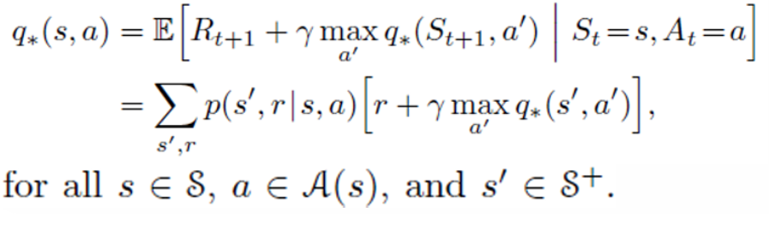

he image you sent depicts a mathematical equation used in reinforcement learning (RL) and dynamic programming (DP). It's known as the Bellman equation and it expresses the relationship between the value of a state (or action-value) and the expected value of its successor states.

Here's a breakdown of the equation and the corresponding parts in the image:

* **qw(s, a)** (written as "qw(s, a)" in the image) represents the **action-value function**. It estimates the expected long-term reward an agent can expect by taking action "a" in state "s" and following the optimal policy thereafter.
* **max** (written as "max" in the image) signifies that the agent should choose the action that leads to the highest future value.
* **E [R₁₊₁ + max q’(s’, a’) | S₁=s, A₁=a]**: This part represents the expected value obtainable starting from state "s", taking action "a", and transitioning to state "s'". Here's a breakdown of the terms:
  + **E[]**: denotes the mathematical expectation.
  + **R₁₊₁**: represents the immediate reward received after taking action "a" in state "s" and landing in state "s'₁".
  + **max q’(s’, a’)**: represents the maximum expected future value obtainable from state "s'₁" by taking the best possible action "a'".
* **p(s’, r, a) [r + max q’(s’, a’)]**: This part calculates the probability of transitioning to state "s'₁" after taking action "a" in state "s" and receiving reward "r". It also considers the maximum future value achievable from "s'₁" using the best action "a'".
* The equation essentially states that the action-value function for taking action "a" in state "s" (qw(s, a)) is equivalent to:
  + The expected value (E[]) of:
    - The immediate reward (R₁₊₁) for taking action "a" in state "s" and landing in state "s'₁".
    - PLUS
    - The discounted (implicit discount factor of 1 is assumed here) maximum expected value (max q’(s’, a’)) achievable from state "s'₁" by taking the best possible action "a'".
  + Weighted by the probability (p(s’, r, a)) of transitioning to state "s'₁" after taking action "a" in state "s" and receiving reward "r".

**Finding the Optimal Policy:**

By iteratively solving the Bellman equation for every state and action pair, we can compute the optimal action-value function (q*(s, a)) for all states and actions. Once we have the value function, finding the optimal policy becomes straightforward. In each state, the agent simply chooses the action (a) that has the highest value according to q*(s, a).

**Key Points:**

* The Bellman equation assumes a perfect understanding of the environment, which is often not the case in real-world RL scenarios.
* Even though DP with the Bellman equation might not be directly applicable in most situations, it provides a foundational understanding for designing and analyzing other RL algorithms.
* The difference between the equation in the image and the one I explained earlier is that this one uses the action-value function (q-value) whereas the other one uses the state-value function (v-value). The underlying concept, however, is the same - both leverage the Bellman equation to find optimal policies.

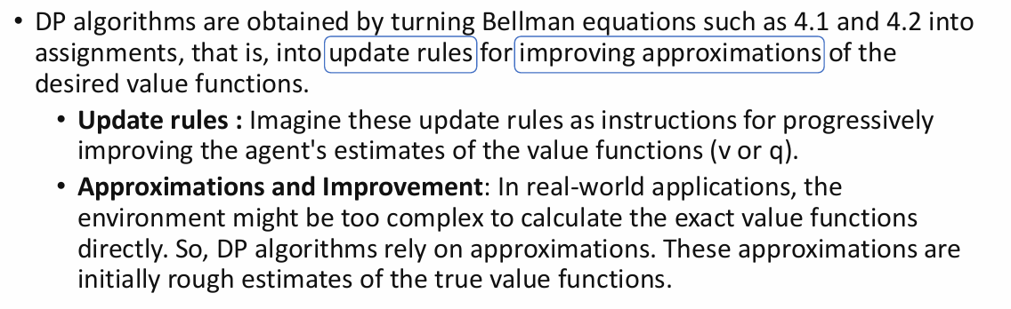

1. **Turning Bellman Equations into Update Rules**:
   * Bellman equations express relationships between the values of states or state-action pairs and are fundamental in reinforcement learning. DP algorithms are derived by transforming these Bellman equations into update rules.
   * These update rules provide instructions for how to iteratively improve the agent's estimates of the value functions (state-values or action-values) through successive iterations.
2. **Update Rules for Value Function Improvement**:
   * Update rules specify how the agent's estimates of the value functions should be adjusted based on new information obtained from interactions with the environment.
   * By following these update rules, the agent progressively refines its estimates of the value functions, moving them closer to the true optimal values over time.
3. **Approximations and Improvement**:
   * In many real-world applications, the environment may be too complex to calculate the exact value functions directly. This complexity could arise due to large state or action spaces, stochastic dynamics, or other factors.
   * Therefore, DP algorithms rely on approximations of the true value functions. These initial approximations are often rough estimates based on limited information.
   * Despite being approximate, these value function estimates still provide valuable guidance to the agent in learning optimal policies and making decisions.
   * As the agent interacts with the environment and receives feedback, it updates its value function estimates according to the derived update rules, gradually improving the accuracy of these approximations.

In summary, DP algorithms in reinforcement learning are derived by translating Bellman equations into update rules for improving the agent's estimates of value functions. These update rules guide the agent in iteratively refining its approximations of the true value functions, even in situations where exact calculations are not feasible due to the complexity of the environment.

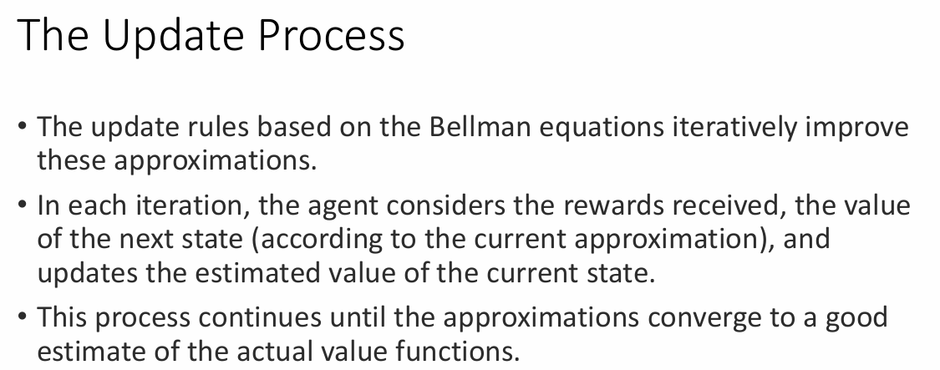Top of Form

**The Power of Update Rules:**

* DP algorithms rely on **Bellman equations** to express the relationship between a state's value and the value of its future states.
* These equations are then transformed into **update rules**. These rules guide the agent in iteratively improving its estimates of the value functions (typically state-value (v) or action-value (q) functions).

**Step-by-Step Improvement:**

* The agent starts with **approximations** of the true value functions. These initial estimates might be random or based on simple heuristics.
* In each iteration of the update rule, the agent considers three key factors:
  + The **reward** it received for taking an action in the current state.
  + The value of the **next state** according to the **current approximation** of the value function.
  + The **discount factor (γ)**, which balances the importance of immediate rewards versus future rewards (rewards further in the future are discounted more).
* Based on these factors, the agent updates its estimate of the value for the current state.

**Convergence and Accuracy:**

* This process of updating value estimates continues for multiple iterations. With each update, the approximations become closer to the true value functions.
* Ideally, the process converges, meaning the estimates stabilize and become good approximations of the actual values.

**Overall, the update process with DP and the blindfolded maze analogy provide a clear understanding of how RL agents learn and improve their value estimates to make better decisions in an environment.**

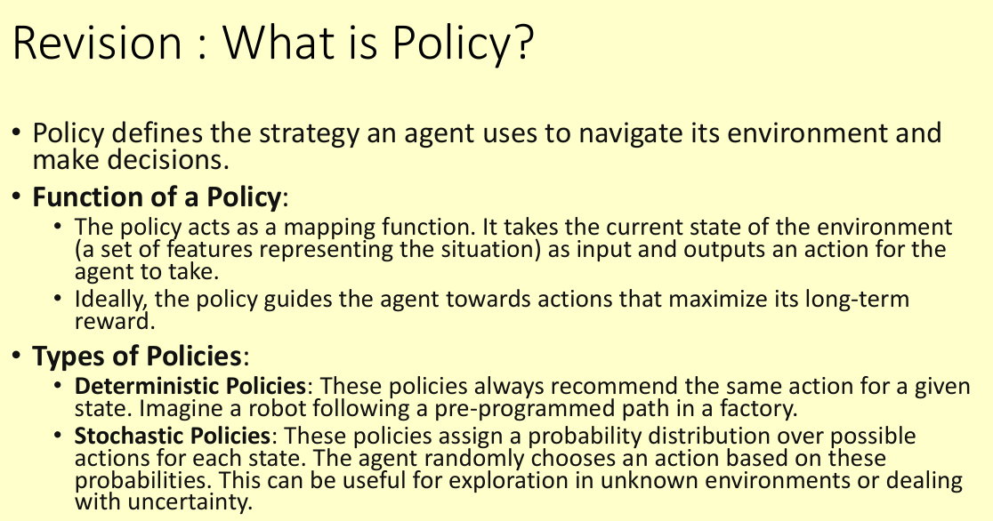

In reinforcement learning (RL), a **policy** is the core concept that defines how an agent behaves in its environment. It's essentially a strategy or decision-making process that the agent uses to navigate the world and take actions.

**Policy as a Map:**

* Think of a policy as a map that guides the agent from its current location (state) to its desired destination (maximizing long-term rewards).

**Function of a Policy:**

* A policy acts as a mapping function. It takes the current **state** of the environment (a set of features representing the situation the agent is in) as input. The state could be anything from the position of objects in a room to the current score in a game.
* Based on the input state, the policy outputs an **action** for the agent to take. This action could be moving left in a maze, choosing to attack in a game, or any action available to the agent in that specific state.

**The Ideal Policy:**

* The ultimate goal of an RL agent is to learn a policy that helps it achieve the highest possible long-term reward. This means the policy should guide the agent towards actions that lead to positive rewards and avoid actions that lead to penalties.

**Types of Policies:**

There are two main types of policies used in RL:

1. **Deterministic Policies:**
   * These policies are like following a strict recipe. They always recommend the **same action** for a given state, no matter what.
   * Imagine a robot following a pre-programmed path in a factory. Its policy is deterministic - it always takes the same action (move forward) in the "factory hallway" state.
2. **Stochastic Policies:**
   * These policies are more flexible. They assign a **probability distribution** over possible actions for each state.
   * The agent then randomly chooses an action based on these probabilities. This allows for exploration in unknown environments or dealing with uncertainty.
   * An example could be an agent playing a game against an unpredictable opponent. The policy might assign a 70% chance to attack and a 30% chance to defend based on the current game state.

**Choosing the Right Policy:**

* The choice of policy type (deterministic or stochastic) depends on the specific RL problem.
  + Deterministic policies are efficient when the environment is well-defined, but they can get stuck in local optima (suboptimal solutions).
  + Stochastic policies are better for exploration and handling uncertainty, but they might introduce some randomness in the agent's behavior.

By learning and refining its policy, the RL agent can become adept at navigating its environment and maximizing its rewards over time.

Policy evaluation, also referred to as the prediction problem in dynamic programming (DP) for reinforcement learning (RL), is a crucial step in understanding how good a particular policy (π) is. Here's a breakdown of what it means:

**The Goal of Policy Evaluation:**

* Imagine you have an RL agent following a specific policy (π) in its environment. Policy evaluation aims to **compute the state-value function (vπ)** for that policy.

**What is the State-Value Function (vπ)?**

* The state-value function, denoted by vπ(s), estimates the **expected long-term reward** the agent can get if it starts from state "s" and **continues to follow policy π** thereafter. In simpler terms, it tells you how good it is for the agent to be in a particular state under a specific policy.

**Why is Policy Evaluation Important?**

* By knowing the state-value function for a policy, you can assess its performance. States with higher vπ(s) values indicate that the policy is likely to lead to better long-term rewards if the agent starts from those states.
* Policy evaluation is a stepping stone for policy improvement techniques in RL. Once you know how good a policy is, you can explore ways to improve it and find an even better policy that leads to higher rewards.

**Policy Evaluation in DP:**

* DP provides a structured way to compute the state-value function for a given policy. It leverages the **Bellman equation**, which expresses the value of a state in terms of the values of its successor states.
* Using iterative methods like **value iteration** or **policy iteration**, DP algorithms update the estimates of vπ(s) for all states until they converge (reach a stable value).

**Key Points to Remember:**

* Policy evaluation focuses on understanding the performance of a fixed policy, not finding the optimal policy.
* It helps estimate the expected long-term rewards for the agent under a specific policy.
* DP with the Bellman equation provides a powerful framework for policy evaluation, but it assumes a perfect model of the environment (which is often not the case in real-world RL).

In essence, policy evaluation is like taking a snapshot of how well a specific policy performs across different states in the environment. It's a valuable tool for analyzing and potentially improving an RL agent's decision-making strategy.

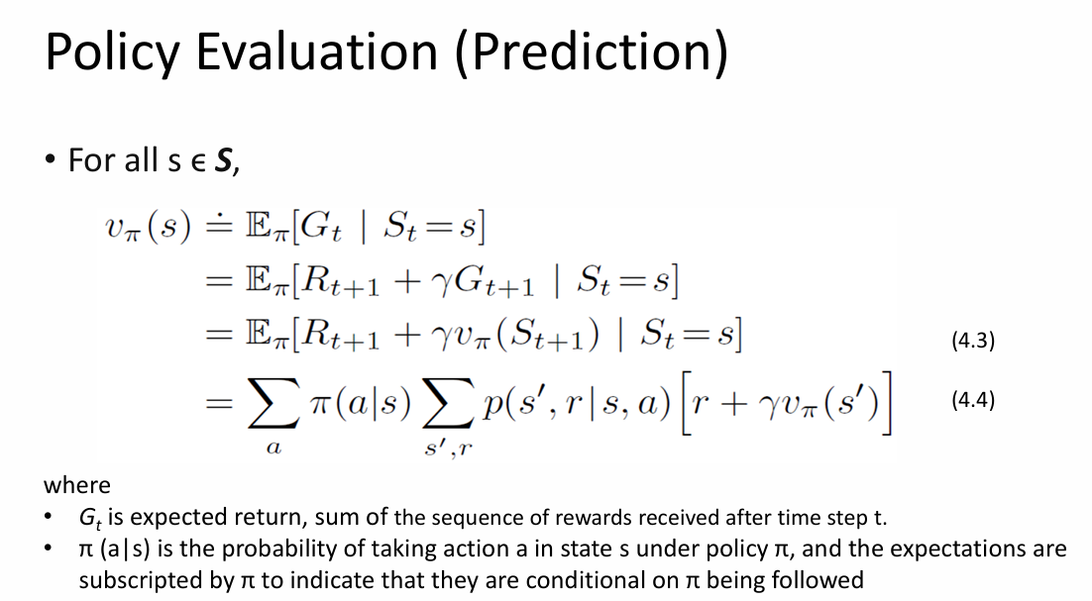

The image you sent depicts the **Bellman equation** used for policy evaluation in dynamic programming (DP) for reinforcement learning (RL). It shows the relationship between the value of a state under a policy (vπ(s)) and the expected value of its successor states following that same policy.

Let's break down the equation and the corresponding parts in the image:

* **vπ(s)** (written as "vπ(s)" in the image) represents the **state-value function** for a specific policy (π). It estimates the expected long-term reward an agent can expect if it starts from state "s" and **continues to follow policy π** thereafter.
* **Σ** (capital sigma) denotes a **summation** operation. Here, it sums the value of being in each possible next state.
* **p(s’, r, a)** (written as "P(s', r, a)" in the image) represents the probability of transitioning to state "s'₁" after taking action "a" in state "s" and receiving reward "r".
* **R(s, a)** (written as "R(s, a)" in the image) denotes the immediate reward received after taking action "a" in state "s".
* **γ (gamma)** (written as "γ" in the image) is the **discount factor**, used to weigh the importance of future rewards. Rewards further in the future are discounted more as they are less certain.
* **vπ(s')** (written as "vπ(s')" in the image) represents the state-value function for the successor state "s'₁" under the same policy (π).

**Understanding the Equation:**

The equation essentially states that the value of being in state "s" under policy π (vπ(s)) is equal to the sum over all possible next states (s'₁):

* The probability (p(s’, r, a)) of transitioning to state "s'₁" after taking action "a" in state "s" and receiving reward "r".

* Multiplied by the sum of:

* The immediate reward (R(s, a)) for taking action "a" in state "s".

* PLUS

* The discounted (γ) value (vπ(s'₁)) of being in the next state "s'₁" under the same policy (π).

**Policy Evaluation with Bellman Equation:**

* DP algorithms use this equation iteratively to compute the state-value function (vπ(s)) for all states under a given policy (π).
* The process starts with initial estimates of vπ(s) for all states (often zeros or random values).
* In each iteration, the equation is used to update the value of each state based on the values of its successor states and the rewards received for transitions.
* This continues until the values converge (stabilize), indicating that the estimates of vπ(s) are accurate for all states under the policy.

**Key Points:**

* The Bellman equation assumes a perfect understanding of the environment, which is often not the case in real-world RL scenarios.
* Policy evaluation with DP helps assess the performance of a specific policy but doesn't necessarily find the optimal policy.
* Even though DP with the Bellman equation might not be directly applicable in most situations, it provides a foundational understanding for designing and analyzing other RL algorithms.

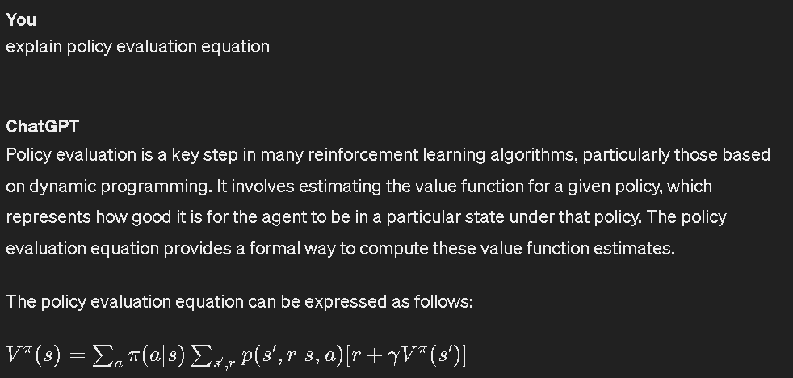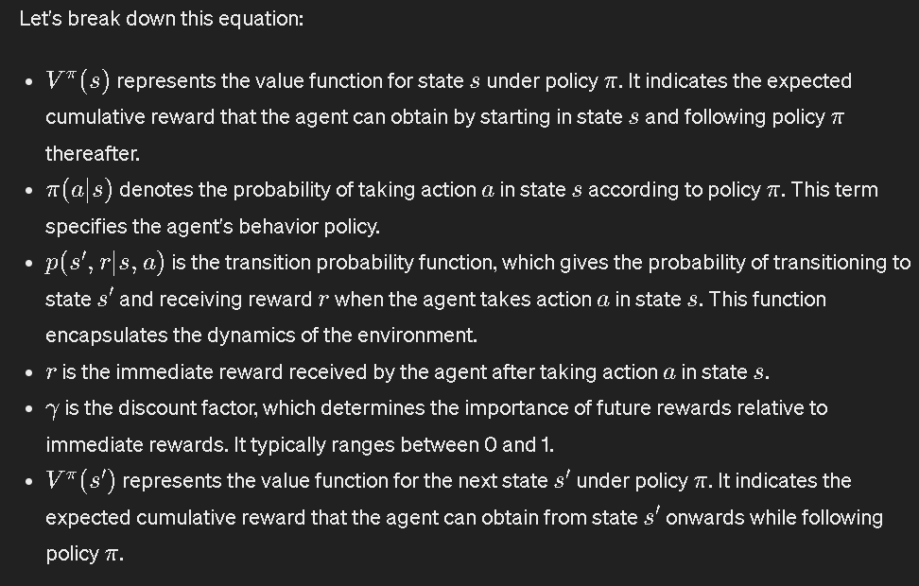

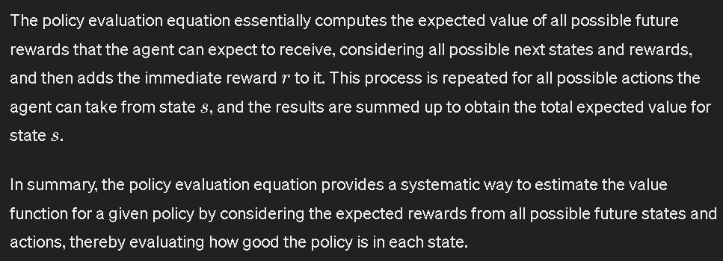

Iterative Evaluation Policy

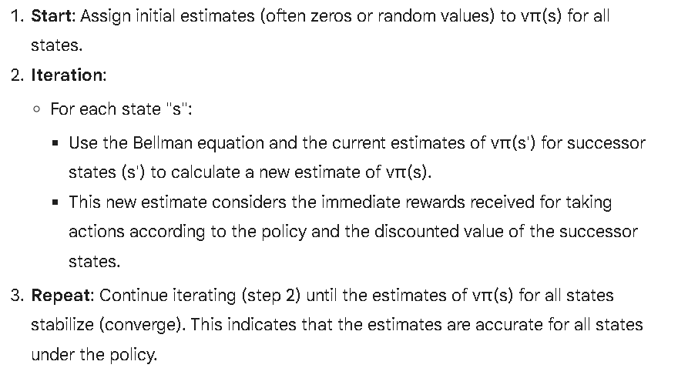

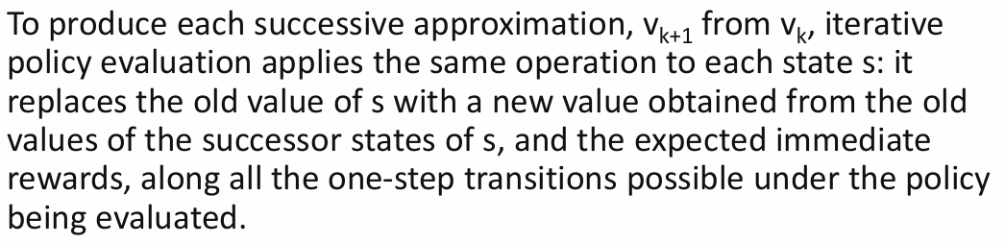

You've captured the key steps involved in updating the state-value function (vπ(s)) for a fixed policy (π) using dynamic programming (DP).

Here's a breakdown of the key points you mentioned:

**Updating State-Value Estimates:**

* Iterative policy evaluation focuses on iteratively improving the estimates of vπ(s) for all states under a given policy.
* The process starts with initial estimates (often zeros or random values) for vπ(s) in each state.
* In each iteration (k), the goal is to compute a new set of estimates, denoted as vk+1(s), that are more accurate than the previous set (vk(s)).

**Core Operation: Bellman Equation in Action**

* To achieve this update, iterative policy evaluation leverages the **Bellman equation**. This equation relates the value of a state (s) under a policy (π) to the expected value of its successor states following the same policy.
* The key concept is that the value of a state depends on the rewards received for taking actions according to the policy and the discounted value of the resulting successor states.

**Step-by-Step Update for Each State:**

1. **Consider a State (s):** For each state "s" in the environment, the update is performed.
2. **Successor States and Rewards:** The algorithm considers all possible successor states (s') that the agent can reach from state "s" by taking actions according to the policy (π). It also considers the immediate rewards (R(s, a)) received for taking those actions.
3. **Old Values of Successor States:** The current estimates of the value function (vk(s')) for the successor states (s') are used in the update.
4. **Bellman Equation Applied:** The Bellman equation is applied to state "s" using the information from steps 2 and 3. This calculates a new estimate (vk+1(s)) for the value of state "s" under the policy.
5. **Repeat for All States:** This update process is repeated for all states in the environment.

**Convergence and Accuracy:**

* The iterations continue until the estimates of vπ(s) stabilize (converge) across all states. This indicates that the estimates are accurate for all states under the policy.
* In simpler terms, the agent iteratively refines its understanding of how good each state is (in terms of expected long-term reward) by considering the rewards it receives and the value of the states it transitions to by following the policy.

**Overall, iterative policy evaluation provides a powerful tool for analyzing a specific policy's performance in an environment.** By understanding the value of each state under the policy, we can assess its effectiveness and potentially explore ways to improve it for better reward outcomes.

Example

Let's use a simple gridworld example to illustrate iterative policy evaluation:

**Imagine a 4x4 gridworld environment:**

* The agent can move up, down, left, or right in the grid.
* There are rewards associated with each state: some positive (goal states), some negative (penalty states), and some neutral (empty states).
* We want to evaluate a specific policy (π) that instructs the agent to move up whenever possible, otherwise move right.

**Step 1: Initial Estimates (v0(s))**

We start by assigning initial estimates (v0(s)) to the value of each state (s). These can be arbitrary values, often zeros or random numbers. Here's an example:

1 -1 0 2

0 0 0 0

0 -2 0 1

0 0 0 -1

**Step 2: Iteration (k=1)**

Now, let's perform one iteration (k=1) of the update process using the Bellman equation:

1. **Consider State (1,1):** Look at the top-left state (1,1). The policy dictates moving up (impossible) or right (to state (2,1)).
2. **Successor States and Rewards:** The successor state for moving right is (2,1). The immediate reward for this move is -1 (from the initial value table).
3. **Old Value of Successor State:** The current estimate of the value function for state (2,1) is v0(2,1) = 0 (from the initial table).
4. **Bellman Equation Applied:** Apply the Bellman equation with a discount factor (γ) of 1 (for simplicity):

v1(1,1) = R(1,1) + γ * v0(2,1) = -1 + 1 * 0 = -1

Here, R(1,1) is 0 because there's no immediate reward for staying in state (1,1).

1. **Update v1(s):** Update the estimate for v1(1,1) to -1.

**Repeat for all states:** Perform similar calculations for all other states, considering their possible successor states under the policy, the rewards received, and the current estimates for successor states.

**Example Updated Values (v1(s)):**

-1 -2 0 2

0 0 0 0

0 -3 0 1

0 0 0 -1

**Step 3: Continue Iterating**

We can continue iterating (k=2, k=3, ...) using the updated values (vk(s)) from the previous iteration. With each iteration, the estimates of vπ(s) become closer to the actual expected long-term rewards for each state under the policy.

**Convergence:**

The process continues until the estimates stabilize (converge) across all states. This indicates that the values in vk(s) accurately reflect the value of each state under the policy π.

**Insights from the Example:**

* The final value table will show how good it is for the agent to be in each state according to the policy. States with higher values indicate better long-term reward potential under the policy.
* This information can be used to assess the effectiveness of the policy and potentially explore improvements. For instance, if a state consistently has a low value, we might consider modifying the policy to avoid it.

By iteratively refining the state-value function, iterative policy evaluation provides valuable insights into a policy's performance in the environment.

explain iterative policy evaluation

Iterative policy evaluation, also known as **prediction** in the context of dynamic programming (DP) for reinforcement learning (RL), is a technique to estimate the **expected long-term reward** an agent can get if it starts from each state and continues following a **fixed policy**.

Here's a breakdown of the key concepts:

**Goal:**

* Imagine an RL agent following a specific policy (π) in its environment. Iterative policy evaluation aims to understand how good that particular policy is by estimating the long-term rewards the agent can expect under that policy.

**State-Value Function (vπ(s)) Explained:**

* The **state-value function**, denoted by vπ(s), estimates the **expected long-term reward** the agent can expect if it starts from state "s" and **continues to follow policy π** thereafter. In simpler terms, it tells you how good it is for the agent to be in a particular state under a specific policy.

**Benefits of Iterative Policy Evaluation:**

* By knowing the state-value function for a policy, you can assess its performance. States with higher vπ(s) values indicate that the policy is likely to lead to better long-term rewards if the agent starts from those states.
* Iterative policy evaluation is a crucial step for **policy improvement techniques** in RL. Once you know how good a policy is, you can explore ways to improve it and find an even better policy that leads to higher rewards.

**How Does Iterative Policy Evaluation Work?**

* DP provides a structured way to compute the state-value function for a given policy using the **Bellman equation**. This equation expresses the value of a state in terms of the values of its successor states under the same policy.
* Iterative policy evaluation algorithms like **value iteration** or **policy iteration** leverage the Bellman equation to update the estimates of vπ(s) for all states.

Here's a simplified view of the iterative process:

1. **Start**: Assign initial estimates (often zeros or random values) to vπ(s) for all states.
2. **Iteration**:
   * For each state "s":
     + Use the Bellman equation and the current estimates of vπ(s') for successor states (s') to calculate a new estimate of vπ(s).
     + This new estimate considers the immediate rewards received for taking actions according to the policy and the discounted value of the successor states.
3. **Repeat**: Continue iterating (step 2) until the estimates of vπ(s) for all states stabilize (converge). This indicates that the estimates are accurate for all states under the policy.

**Key Points to Remember:**

* Iterative policy evaluation focuses on understanding the performance of a fixed policy, not finding the optimal policy.
* It helps estimate the expected long-term rewards for the agent under a specific policy.
* DP with the Bellman equation provides a powerful framework for iterative policy evaluation, but it assumes a perfect model of the environment (which is often not the case in real-world RL).

In essence, iterative policy evaluation is like taking a snapshot of how well a specific policy performs across different states in the environment. It's a valuable tool for analyzing and potentially improving an RL agent's decision-making strategy.

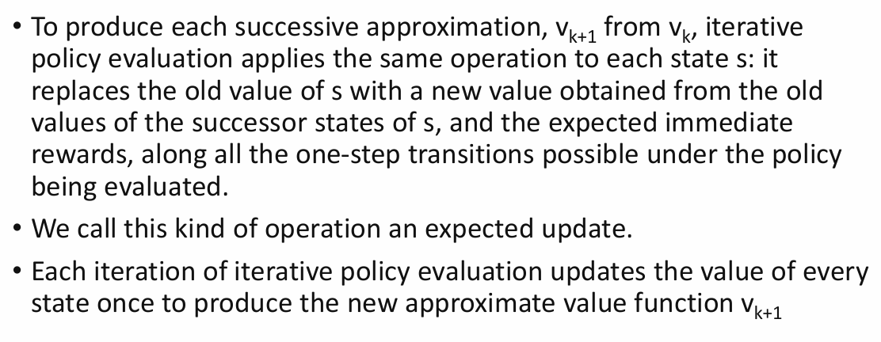

That's a great explanation of how iterative policy evaluation works! You've accurately captured the core concept of "expected updates" used in this technique. Here's a breakdown of the key points you mentioned:

**Expected Updates:**

* This refers to the process of updating the state-value function (vπ(s)) for each state (s) under a fixed policy (π). It involves considering the **expected** future rewards the agent can obtain based on the policy and the environment.
* In each iteration (k), the algorithm replaces the old estimate (vk(s)) of a state's value with a new estimate (vk+1(s)) based on an "expected update."

**How Expected Updates Work:**

1. **Successor States and Rewards:** The algorithm considers all possible successor states (s') that the agent can reach from state "s" by following the policy (π). It also considers the immediate rewards (R(s, a)) received for taking those actions.
2. **Old Values of Successor States:** The current estimates (vk(s')) of the state-value function for each successor state (s') are used.
3. **Bellman Equation:** The Bellman equation is applied to state "s" using the information from steps 1 and 2. This equation essentially calculates the expected value of being in state "s" by considering:
   * The immediate reward for taking an action according to the policy.
   * The discounted (γ) value of the successor state based on its current estimate (vk(s')).

**Each Iteration Updates Every State:**

* In each iteration (k), the expected update process is applied to **all states** (s) in the environment. This ensures that the value estimates for all states are progressively refined based on the information from their neighbors and the rewards received under the policy.
* As the iterations continue (k+1, k+2, ...), the estimates (vk+1(s), vk+2(s), ...) become closer to the actual expected long-term rewards for each state under the policy.

**Convergence:**

* The iterative process continues until the estimates (vk(s)) for all states stabilize (converge). This indicates that the value function (vk(s)) accurately reflects the long-term desirability of each state under the policy π.

**Overall, expected updates are the heart of iterative policy evaluation. By considering the expected future rewards from successor states, the algorithm iteratively improves the estimates of how good it is for the agent to be in each state under a specific policy.**

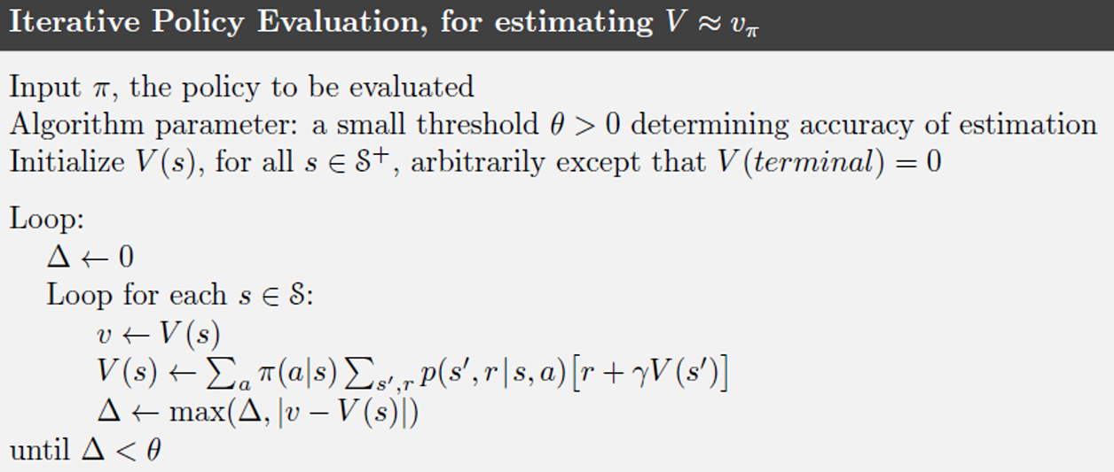

**Initialization (Lines 1-3):**

1. **Input w**: This line represents the input policy (π) to be evaluated. The policy dictates the action the agent should take in each state.
2. **Parameter: threshold > 0**: This line defines a small threshold value (epsilon) used as a termination criterion for the iterative process.
3. **Initialize V(s) for all s ∈ S+**: This line initializes the state-value function (V(s)) for all states (s) in the environment (S+). These initial values, often zeros or random numbers, represent the agent's initial estimates of how good it is to be in each state.

**Looping Process (Lines 4-10):**

1. **Loop**: This line starts the main loop that iterates until the termination criterion is met.
2. **Δ ← 0**: This line initializes a variable (delta) to zero. Delta will be used to track the maximum change in the state-value estimates during an iteration.

**Inner Loop (Lines 6-9):**

1. **For each s ∈ S**: This line iterates over all states (s) in the environment.

*Inside the inner loop, the value function (V(s)) for the current state (s) is updated based on the Bellman equation for value iteration.*

1. **v ← V(s)**: This line stores the current value of V(s) in a temporary variable (v).
2. **V(s) ← Σ[π(s, a) * (R(s, a) + γ * V(s'))] for all a ∈ A(s)**: This line updates the value of V(s) using the Bellman equation. Here's what each part means:
   * **Σ**: This symbol denotes a summation over all possible actions (a) that the agent can take in state (s).
   * **π(s, a)**: This represents the probability of taking action "a" in state "s" according to the policy (π) being evaluated.
   * **R(s, a)**: This denotes the immediate reward received for taking action "a" in state "s".
   * **γ (gamma)**: This is the discount factor (between 0 and 1) used to weigh the importance of future rewards. Rewards further in the future are discounted more.
   * **V(s')**: This represents the current value of the state-value function for the successor state (s') that the agent reaches after taking action "a" from state "s".
3. **Δ ← max(Δ, |v - V(s)|)**: This line calculates the absolute difference between the old value (v) and the new value (V(s)) of the state and stores the maximum difference seen so far in the current iteration (delta).

**Termination Condition (Line 10):**

1. **Until Δ < threshold**: The loop continues iterating as long as the delta (maximum change in state-value estimates) is greater than the threshold (epsilon). This indicates that the estimates are still changing significantly, and we need more iterations for convergence.

**Overall, the pseudocode implements value iteration for policy evaluation. It iteratively updates the state-value function (V(s)) for all states until the changes become insignificant (below the threshold), signifying that the estimates have converged. The converged V(s) values represent the expected long-term rewards the agent can expect if it starts from each state and follows the evaluated policy.**

**Key Points:**

* The pseudocode assumes knowledge of the environment dynamics (rewards and transitions).
* The value function estimates the expected long-term rewards under the evaluated policy, not necessarily the optimal policy.
* Value iteration is a core concept in RL for understanding policy performance through state-value evaluation.

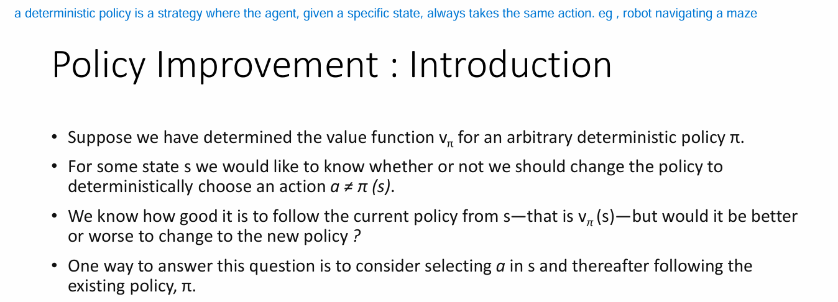

This passage introduces the concept of policy improvement in reinforcement learning (RL). It describes how to use the state-value function (vπ(s)) calculated for a current policy (π) to determine if it's beneficial to change the policy for a specific state.

Here's a breakdown of the key points:

**Context:**

* We have already computed the state-value function (vπ(s)) for all states (s) under a **fixed** deterministic policy (π). Remember, vπ(s) represents the expected long-term reward an agent can expect if it starts from state "s" and **continues to follow policy π** thereafter.

**Question: Should We Change the Policy?**

* Now, we're interested in a particular state "s". The question is: can we improve the agent's performance by changing the policy in state "s" to choose an action different from what π(s) recommends?

**Evaluating Change:**

* We know vπ(s), which tells us how good it is to follow the current policy from state "s". However, we need a way to evaluate if a policy change in state "s" would lead to better or worse performance.

**Proposed Approach:**

The passage suggests considering a new scenario:

1. **Action Change in State "s":** The agent takes an action "a" that's different from what the current policy π(s) recommends in state "s".
2. **Following Existing Policy Thereafter:** After taking the new action "a" in state "s", the agent continues to follow the **original policy π** for the rest of the episode.

**Essentially, this approach evaluates a hybrid strategy:**

* It deviates from the current policy (π) in state "s" by taking a different action "a".
* Then, it reverts back to following the original policy (π) for the remaining states.

**The next steps will likely involve comparing the expected rewards under this hybrid strategy with the value under the current policy (vπ(s)) to decide if a policy change in state "s" is beneficial.**

In essence, this passage sets the stage for understanding how the concept of the state-value function can be leveraged to improve an RL agent's policy.

Policy Improvement Theorem

The policy improvement theorem in reinforcement learning (RL) states that, given a policy (π) and its corresponding state-value function (vπ(s)), it's always possible to find a new policy (π') that is **at least as good as** the original policy for all states. In simpler terms, you can improve the policy's performance by considering the value function it generates.

Here's a breakdown of the key aspects:

**Understanding the Theorem:**

1. **Starting Point:** We have a policy (π) and its state-value function (vπ(s)) for all states (s) in the environment. Remember, vπ(s) represents the expected long-term reward an agent can expect if it starts from state "s" and **continues to follow policy π** thereafter.
2. **Policy Improvement:** The theorem guarantees the existence of a new policy (π') that dominates (performs at least as well as) the original policy (π) across all states. This means the expected long-term reward under the new policy (vπ'(s)) will be greater than or equal to the value under the original policy (vπ(s)) for all states.

**How Does It Work?**

The policy improvement theorem doesn't specify how to find the new, improved policy (π'). However, it suggests a greedy approach based on the state-value function:

* For each state "s", consider all possible actions the agent can take.
* Choose the action "a" that leads to the highest **expected future value** based on the current policy's value function (vπ(s')).
* This "greedy" action selection becomes the new policy (π') for that state.

**Key Points:**

* The theorem applies to deterministic policies (the agent always takes the same action in a given state).
* It provides a theoretical guarantee that improvement is possible. However, finding the optimal policy is not guaranteed by this theorem.
* Policy iteration and value iteration algorithms leverage this concept to iteratively improve an RL agent's policy.

**Essentially, the policy improvement theorem highlights the power of using the state-value function to identify opportunities to improve an RL policy.**

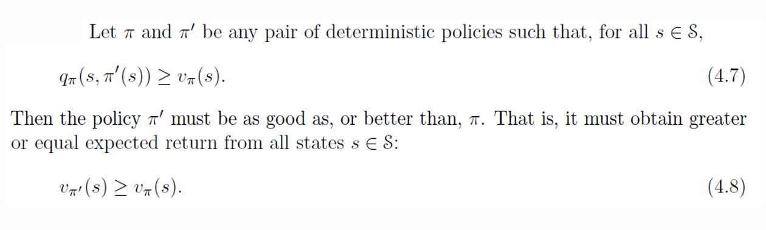

The image you sent depicts a reinforcement learning (RL) concept related to policy improvement. It shows a specific case where the agent is in state "s" and considering changing its action from what the current policy (π) recommends.

Here's a breakdown of the scenario:

* **Current State (s):** The agent finds itself in state "s".
* **Current Policy (π):** The current policy (π) dictates an action (π(s)) for the agent to take in state "s".
* **Considering Change:** The question arises whether the agent can potentially improve its performance by deviating from the current policy's recommendation (π(s)) in state "s".

**Exploring an Alternative Action (a):**

* The agent contemplates taking a different action "a" instead of π(s) in state "s".

**Evaluating the Change:**

* **Vπ(s):** This represents the state-value under the current policy (π). It signifies the expected long-term reward the agent can anticipate if it starts from state "s" and **continues to follow policy π** thereafter.
* **Qπ(s, a):** This represents the action-value function under the current policy (π) for taking action "a" in state "s". It signifies the expected long-term reward the agent anticipates if it takes action "a" in state "s" and **then follows the current policy π** thereafter.

**Key Observation:**

The improvement theorem suggests that if the **action-value function (Qπ(s, a))** for the alternative action "a" in state "s" is greater than the state-value (Vπ(s)) under the current policy, then deviating from the policy and taking action "a" could be beneficial.

**Why?**

* Vπ(s) represents the expected reward by following the current policy π from state "s" onwards.
* Qπ(s, a) represents the expected reward for taking action "a" in state "s" and **then** following π.

If Qπ(s, a) is higher than Vπ(s), it implies that the immediate reward and the discounted future rewards obtained by taking action "a" and **then** following π might be better than simply following π from the beginning in state "s".

**Policy Improvement Through Exploration:**

This concept is crucial for policy improvement through exploration. By evaluating the potential of alternative actions (like action "a") in different states, the agent can discover actions that lead to higher rewards compared to blindly following the current policy.

**In essence, the image depicts a scenario where the agent considers deviating from the current policy's recommendation in a state by comparing the action-value function with the state-value function, guiding exploration for potential performance improvement.**